Press Pack
January 2018
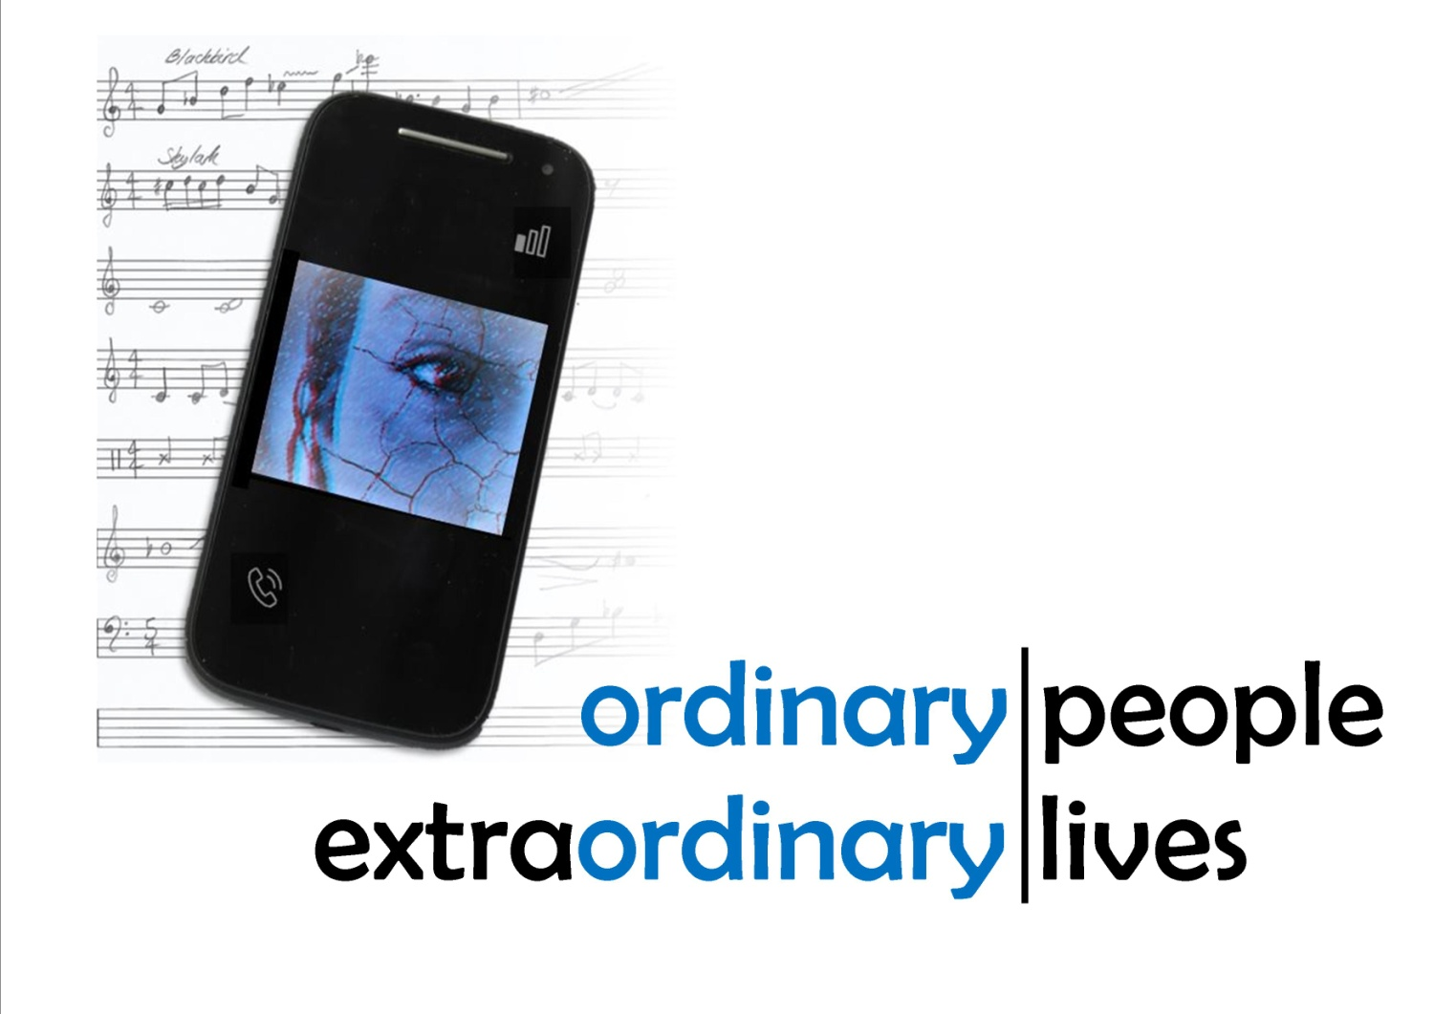

An incredible project...very original! Tobias Brown, Cambridge105
Really fascinating. Thordis Fridriksson, BBC Radio Cambridgeshire
Check out this wonderfully creative project. Royston and District Museum

In brief
Cracked Voices is a new sixty-minute song cycle* centred on South Cambridgeshire and North Hertfordshire, funded by the Arts Council of England and the PRS Foundation.

Based on Graham Palmer's original research, this ‘incredible project’ (Cambridge105) gives voice to forgotten characters from the borderlands of Hertfordshire and Cambridgeshire.

It focuses on the extraordinary lives of ordinary people.
From Servandus waiting on his lost Celtic goddess at Ashwell, to the POWs celebrating Hitler’s birthday on Therfield Heath. From James Lucas’s confrontation with Charles Dickens to Joyce Hatto’s scandalous recordings.
Set to music by Cambridgeshire composer Jenni Pinnock, the songs feature a tangle of quirky time signatures and memorable lines, focusing heavily on nature and the world around us.

Premiere
Cracked Voices will premiere at Anglia Ruskin University on 10 March 2018, with performers Miles Horner (baritone), Donna Lennard (soprano), Sue Pettitt (clarinet) and Ralph Woodward (piano).

Benefit concert
Cracked Voices will also be performed at a benefit concert on 28 April 2018. Organised and hosted by the Methodist Church (Royston),ticket money will go to aid the MindEd Trust, a teenage mental health charity set up in memory of local teenager Edward Mallen. This concert will culminate with the premiere of 'Cracked Objects' (art songs written by year 10 pupils from Meridian School under the guidance of Graham Palmer and Jenni Pinnock).

Pop-up talks
Free pop-up talks featuring the stories behind individual songs will take place at Royston Museum on Saturday 24 February and the Sedgwick Museum (Cambridge) on Saturday 3 March.

*A song cycle is a set of linked art songs. An art song is simply a poem set to music.
The stories and people behind the songs

Those who wait | Servandus
Servandus son of the Spaniard willingly fulfilled his vow to the goddess
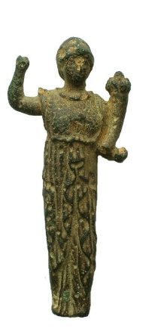
Many hundreds of miles from home, one man makes his offering to Senuna. We know nothing more than his name, which means both the person who watches over things and the preserver. His voice has long been silenced.
In 2002 a metal detector bleeps. Alan Meek has chanced upon a horde of votive gifts. Carefully, he disinters Servandus's offering and the goddess's cracked and broken statuette from its hiding place at Ashwell End.
Senuna has not seen light of day for sixteen hundred years. Some say she is the Celtic equivalent of Roman Minerva, but her history is buried deep...a mystery, just like Servandus.
Riddle the first | Etheric
Beaten for the silence I steal -
I am the cup that spills sorrow and joy.
With prayerful mouth and enduring noise,
mine is the fateful summoning voice.
Tethered yet ethereal -
no fruit in the Garden so readily peels.
Etheric was still a young boy when his parents sent him off to study at Ramsey Abbey, and he and three playmates - Athelstan, Eadnoth and Oswald - soon fell foul of the abbey's strict rules.
Was it a dare? Who touched a bell rope first? Egging each other on, they pulled harder and harder, the bells rang louder and louder, until - disaster - the great bell cracked.
The monks were furious. They wanted the culprits flogged, but the Abbot stopped himself, realising that some good might grow out of the boys’ remorse. Many years later, it did.
[This is the first of three riddles telling the story of Therfield Heath. The other two tell of how Etheric redeemed himself and how today we walk our dogs, jog, play rugby and watch wildlife, unaware that this semi-wild fragment of land survives solely because of a schoolboy’s prank.]
The Ballad of Alice Stokes | Alice Stokes
On 4 August 1604, Christina and Alice Stokes were hanged at Hertford. Terrified and almost certainly tortured, they had confessed to being witches.
King James of Scotland had come to the English throne only three years earlier. On his journey south he had stopped in Royston and taken note of the good hunting to be had on the extensive heathlands. This was a man who was fascinated with witchcraft.
He quickly established a bachelor pad on Kneeworth Street and visited often. What could be better for the town's fuddle-caps and maltworms (drunken menfolk) than to serve him up with two of Royston's most troublesome women to hang?
Composite Man | Louisa Seabourne
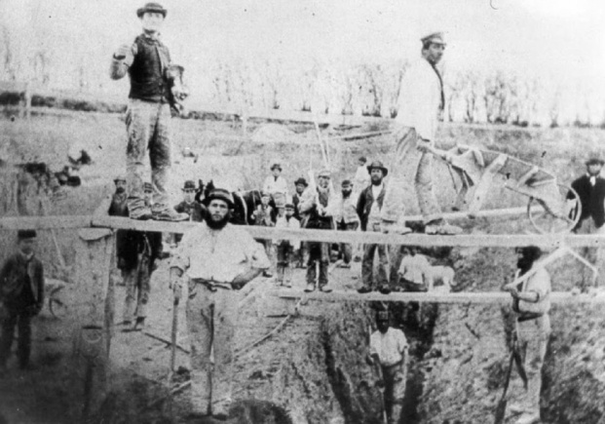
In the 1870s fossils of all sorts - including hippopotamus bones - were being dug out of the ground at Barrington and beyond. Soon the Sedgwick Museum in Cambridge had enough bones from different hippopotamuses to construct a complete skeleton. By fixing them all to a specially-made metal armature they created their own Frankenstein's monster: a composite animal.
But the Coprolite Pits were not about finding exhibits. The burgeoning population needed food and the fossils, when ground-up and treated with chemicals, were a highly effective, and highly profitable, fertiliser. Fossils were a cash crop.
At the workings, the labourers hand-dug trenches up to 6 metres deep before collapsing the exposed face. Accidents were commonplace and many men were buried alive... enough to form a composite man. This is his and his wife's song.
Most of the dead men have no memorial other than the churches that were refurbished with the profits from their industry.
These are some of their names: Arthur Wellington Reach (aged 6), John Rayner, William Lander, James Dawson, James Mann, William Wilson, James Rayner, James Barton, (aged 21), Richard Barlow (aged 11), John Swann (aged 60), James Day (aged 25), William Starbuck (aged 9), Robert Napsey (aged 19), Thomas Lovell (aged 36), James Fortune, Moses Waller, William Crane, George Aspen (aged 26), George Hills (aged 61), William Clarke, John Dockrey (aged 18), William Hines (aged 25), Edward Wilkin (aged 23), George Wright, Henry Ginn (aged 37), a boy named Parker, Wheeler Ambrose (aged 46), George Fuller (aged 27), William Wright, Harradine Sell (aged 47) ... and others, unknown.

A Doubtful Loss |James Lucas

The hermit Lucas is dying...on the death of his mother, about 25 years ago, he excluded himself from the world, and has continued so ever since. During that time he has lived literally in sackcloth and ashes, never wearing any clothes beyond a blanket, and totally ignoring the use of soap and water. Some years ago the late Charles Dickens paid this notorious character a visit, and immortalised it in his "Tom Tiddler's Ground."
- Western Mail, Tuesday 21 April 1874
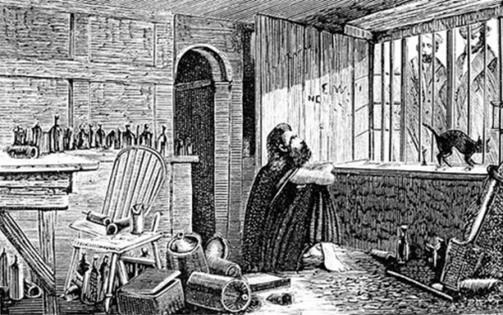
James Lucas was a highly intelligent man who lived a secluded life at Redcoats Green near Hitchin. Although the term had not yet been coined, he was almost certainly a paranoid schizophrenic. Believing that his brother was responsible for his mother's death and was plotting to kill him, he had shut himself up in his country house, barred its windows and let it slowly rot around him. In time the ruin became a tourist attraction with people travelling from far and wide to stare in at the ragged man and snidely comment, 'Does it do tricks?'
When he visited in the summer of 1861 Charles Dickens came away with a less than favourable impression of The 'Hertfordshire Hermit'. Lucas did not suffer fools gladly, especially such a famous fool as Dickens. (The man who was just then earning his money from the serialisation about another strange recluse called Miss Havisham). Undoubtedly, the great writer felt snubbed. He hated the hermit's indolence and, that winter, published a damning account of his visit in a special Christmas edition of his own magazine. Lucas, himself, never admitted the meeting but was later seen with his own well-thumbed copy of 'Tom Tiddler's Ground'. That piece cemented Lucas's reputation as a man who had squandered both his life and his wealth. On hearing of Lucas's fatal illness, the The Times ran the news under the headline, A Doubtful Loss.
(While the insults in this song come directly from Charles Dickens' pen, James Lucas's comments are fictional.)
The blessing of the road-born child |Maria Holtzmann
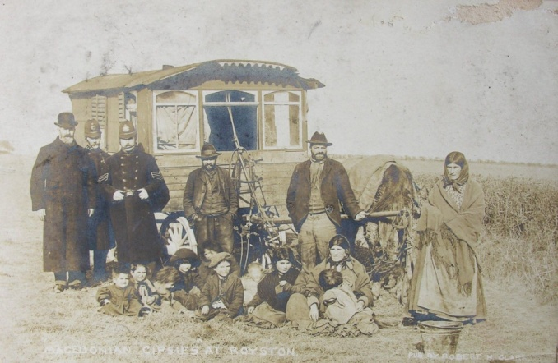
When I was young I remember we were let out of school very early because the Macedonians were on their way. I ran all the way home because I was so frightened. - Minnie Roberts

On Thursday 1 December 1904, five refugee families made landfall next to the Tower of London. Displaced, they were escaping from harsh new laws that the German government was enacting against travellers (a process that soon saw all gipsies fingerprinted and eventually led to Hitler's death camps). Some in Britain were welcoming, but most were not. Although the border was open, at Westminster the politicians were arguing over a new Aliens Act which would for the first time limit immigration. No-one knew who these uninvited visitors were, and, since there was fierce fighting in the Balkans, the sensationalist press were quick to label them 'Macedonians'.
Local authorities wanted nothing to do with them and around London and East Anglia great crowds came out to gawp at the gipsies as they were forced to move on by the police from one county to another. When they crossed the county line at Royston the entrepreneurial Robert H. Clark was there with his camera and the postcards he produced 'had a very large sale' (Royston Crow). At Epping the gipsies were stoned and one child suffered a bad head wound. At St Albans a crowd of around 800 gathered and it was only the presence of large numbers of police 'that saved them from being roughly treated' (Official Police Report).
In the snow of that spring, one of the women gave birth. The apparently healthy baby girl quickly developed such bad catarrh that she could not feed. Despite Anna Holtzmann's desperate efforts, her daughter slowly starved to death. On 13 March 1905, eight-day-old Maria was buried at Great Brickhill. The Luton Times and Advertiser commenting, 'Such folk would not be allowed to land in the United States, but until the long-delayed Aliens Bill is passed, other places will have the experience of Great Brickhill.'
Britain was turning inward. The Aliens Act - the first legal curb on the freedom of displaced people seeking refuge - became law on 11 August that year. Its effect is still felt today.
Domestic Economy |William Stockbridge
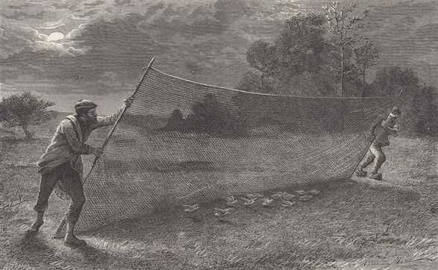
During a normal winter at Thriplow the 72 year-old chimney-sweep William Stockbridge could expect to snare a few songbirds for his cooking pot. This was not a normal winter, though. Severe blizzards over the Baltic were having a strange effect on counties in the east of England. As well as bitingly cold weather, a deep cyclone over Sweden was driving millions of skylarks across the North Sea. It had happened once before in living memory and now again, in 1912, the birds were settling in huge numbers on the open fields and heathland from Duxford to Baldock, scrabbling for whatever food they could find in the hard frost. In London larks were considered a culinary delicacy, a dish that the rising middle-classes should aspire to serve at their dinner parties (as promoted by Mrs Beeton's famous Book of Household Management). Sensing a profit, locals now flocked to harvest the hungry birds. When the sun had set, pairs of men, one at each end of a thirty foot trammel net would trawl the fields, dropping the net suddenly as the frightened birds flew up into it. The national newspapers were soon reporting that in one week alone 30,000 dead birds (one and a half tons) were sent to London by train from Royston. Stockbridge, the only man prepared to talk about the slaughter, was dubbed 'the doyen of lark-snarers' and held up to both criticism and ridicule. After investigation by the Royston Crow, it was later admitted in Parliament that the papers had got it wrong and the numbers caught, though staggering, were far fewer than had been initially claimed. It took a further ten years for the RSPB to persuade Harrods to stop stocking skylarks. Due to changes in crops and farming methods over the last century, there has been a drastic decline in larks but they can still regularly be heard warbling over Therfield Heath.
Many of William Stockbridge's words are his own, as reported in the London Daily News. The recipe for lark pie given in the song is adapted from Mrs Beeton.
The devil and the draper | Sidney Powell's shindy
Church Hill the highest on Royston Heath, is supposed to be the same height as the Church, hence its name. At the base may be seen the perfectly formed beds called the devils Hopscotch. Tradition says by hopping round them nine times without stopping his Satanic Majesty will appear. - Hertford and Bedford Reformer, Saturday 31 July 1841
...an excavation was made on top of Church Hill... About 2¹/₂ ft from the top was a deep cleft to the N.W. side, filled with clay. At the same depth was found ashes and charcoal, with fragments of a British urn baked outside, and a skeleton of a man supposed to be near 6 ft. high; the skull was protected by a large flint...A flint arrow head was afterwards discovered.
- Royston Crow, 2 October 1865
The town has not yet recovered from the painful shock which it received on Tuesday morning when it became known that Mr Sidney Powell, only son of Mr and Mrs C Powell, of 'Westry', had been found dead on the Heath...under tragic circumstances.
- Herts and Cambs Reporter, Friday August 23, 1912

Jesus from Hut 7|Klaus Kellner
Klaus Kellner was...not sulky, nor argumentative, and seemed to fit in fairly well with the other prisoners in his hut. Then, quite suddenly... he 'got religion'...He let his hair grow long, and in this age of cropped heads, his mane of copper locks looked distinctly odd. He gave up shaving, and soon had a full reddish tinged beard....He wrote out such bits of the Bible as he could remember...and he bound them together with two bits of cardboard. Armed with this, he went from hut to hut attempting to preach...Most of the time he was kicked out...In time, he came to be known as 'Jesus from Hut 7' and in his appearance and manner, he grew more and more like one of the ancient Prophets.
- Alfred J Christiansen, POW
Unpublished Memoir (IWM Archive)
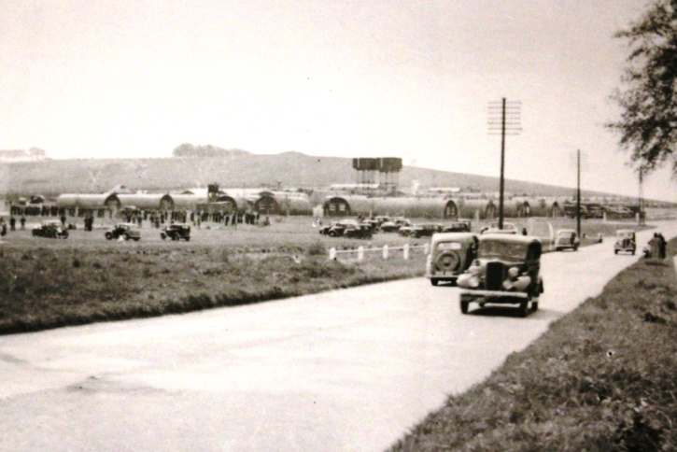
Despite the barbed-wire, water-tower and breezeblock huts with corrugated iron rooves, Camp 29 was not there. For the whole of the Second World War it did not exist. It was definitely not on the heath a few hundred yards from Royston's High Street. Not one newspaper dared mention its construction or the six hundred Italian, and then German, Prisoners of War living behind its fences. Marked out by a coloured patch on their chocolate brown uniforms, prisoners such as Klaus Kellner and Alfred J Christiansen existed there in limbo, only ever permitted out under guard to work for the enemy on the nearby labour-starved farms. In return, they were paid in plastic discs which they exchanged at the canteen for tobacco, razor blades or sickly-sweet cake. As bombers from the neighbouring airfields grouped high above the camp, the inmates tried to keep busy to block out any thought of their families back home and where the planes were headed. Apart from endless games of football, the inmates spent their time putting together a make-shift theatre and the British camp commandant supplied a ropey piano. Things ticked along while sport and the arts made not thinking easier.
But early in 1945 a sudden intensive search of the camp by an outside British Army unit changed everything. Men's belongings were rifled, the theatre was all-but destroyed. Nothing untoward was found. It would take weeks for the camp to get back to normal and in Hut 16 the intrusion rankled deeply. The balance had been disrupted and would only be restored with an equally obnoxious act of defiance. All it took was a sheet, some pillow cases and a few bottles of ink. That April, on Hitler's birthday, locals woke to find, fluttering from the camp's watertower, a full-size German swastika. Needless to say, it was never reported.
A distant murmuration |Joyce Hatto's lament
On her death in June 2006, The Guardian described Joyce Hatto as 'one of the greatest pianists Britain has ever produced.' The 77-year-old Roystonian had been suffering from cancer for thirty years. The treatment was increasingly debilitating and prevented her from giving concerts. Nevertheless, her hundred odd CDs revealed an unbelievably versatile talent.
It was not until the following February that the truth was revealed. In New York, Brian Ventura put a Hatto CD into his computer and waited for it to load. When he looked up, he was amazed to find that iTunes had identified the recording as one by a little-known Hungarian called László Simon.
Recording after recording proved to be have been faked by Hatto's sound-engineer husband, William Barrington-Coupe. Later he was to claim that his wife had no knowledge of the fraud. 'I simply let her hear… the finished editing that she thought was completely her own work.' No-one will ever know whether Joyce either knew or guessed what was done in her name.
Earthrise | Edward Mallen
There is an old French folktale. The kingfisher was created a muddy brown or grey bird, not colourful at all. When the flood came, it travelled with the other animals on the Ark and Noah released it at the same time as the dove to look for land. After being cooped up for so long, it was overjoyed by the sense of release. It flew so high that it scorched its breast on the sun and scraped the blue from the sky. Eventually it remembered it was meant to return with news of land and it flew down to find Noah. However, the Ark was gone and the kingfisher has been searching for it ever since.
Edward Mallen was an academically and musically gifted 18 year old from Meldreth. He was curious about everything, tenacious and focused, and enjoyed travelling, playing cricket and birdwatching and often visited the hides at RSPB Fowlmere to watch the kingfishers. Given his wide knowledge and enquiring nature, he probably knew that it is the play of light on the kingfisher's feathers that makes it appear blue. A joyous sight.
In February 2015, following the unexplained, rapid and catastrophic onset of depressive illness, Edward took his own life. His case highlighted the urgent need for training and investment in teenage mental wellbeing. In response his family set up the MindEd trust to do just that. (TheMindEdTrust.org)
Curating the collection | Each of us
We are all curators and these are just a few objects, one for each of the Cracked Songs. As we write and rewrite history, we select and shape, create our own myths. We choose what to save - what to put on display. Sometimes it is the things we discard or try to forget that tell us most about ourselves.

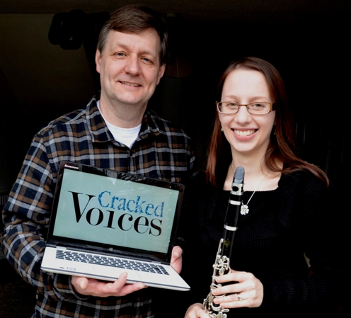
The creators of Cracked Voices
Graham Palmer - Researcher/Writer
Starting in the small press world of the 1980s, Graham co-founded Stride Magazine – one early reviewer commenting, ‘Palmer has the impressive gift of word economy, using a stark interplay of image and lyric to produce poems of depth and beauty.’

Since then he has dabbled with journalism and reviewing, written an ‘incisive’ study-guide on the Hound of the Baskervilles (so says the Sherlock Holmes Society of London) and published three books on writing for language-learners with Cambridge University Press, one of which was chosen by the English Language Gazette as their ‘Book of the Month’.

His original research featured in the centennial Book of the Old Edinburgh Club and the creation of myths, how the past informs or misinforms the present, has been one of his consistent themes. In addition to Cracked Voices, he is currently working on a historical biography.
www.creativehertfordshire.com/graham-palmer-writer/
Jenni Pinnock - Composer
British composer Jenni Pinnock’s music has been described as ‘refreshing’, ‘imaginative’ and ‘tantalizingly beautiful in smoothness and soul’. Quirky time signatures, soaring melodies and moments of quiet stillness can all be found within her music which has received performances both across the UK and around the world. She is passionate about music in all forms, and loves writing for and collaborating with artists and musicians – be they beginners, amateurs or seasoned professionals. Giving performers the artistic freedom to make the music their own is an important element of her work.
Jenni studied at Kingston University and Trinity Laban Conservatoire of Music and Dance. In recent years she has had works performed by the Aldworth Philharmonic Orchestra, Red Note Ensemble, the Quangle Wangle Choir and Equinox Voices. In 2017 she also had her carol Christmas Bells recorded by the Kantos Chamber Choir for their Silver Stars at Play album. Alongside composing she runs music and composition workshops, performs with local ensembles and teaches piano and woodwind.

In addition to Cracked Voices, Jenni is part of the composing team working on Ada Lovelace: the musical. She is also a mentor for Making Music’s Adopt a Composer scheme.
www.jennipinnock.com
The making of Cracked Voices
Graham Palmer says...
Back in 2015 a tweet pinged onto my twitter feed from a composer searching for words. As these things do, it distracted me for five seconds. I was currently doing a Sherlock on the mysterious earthworks on the heathland near Royston...interesting in an academic sort of way, but it wasn't going anywhere.

Then, trawling through the British Newspaper Archive, I came across an article from 1912 about the death of a local man called Sidney Powell..I knew instantly that what I was writing was not about some forgotten lump in the ground, it was Sidney's story.

A direct message, an email exchange and a meeting later and Jenni and I decided that this forgotten draper should have his own song. The following summer, sat in a concert at Meridian School, with the chamber choir blasting out their joyously folky rendition of The Devil & the Draper, we thought maybe, just maybe, this idea might have legs...

Choices were haphazard. The people must be ordinary. They must have lived within a confined area. They must be a mixed bunch. History buries women much deeper but I wanted to try for a mix of ages and genders. What mattered most was that there was a spark, each most have some small thing that made these people's lives extraordinary.

Jenny Pinnock says...
Setting Graham’s captivating poems was both a joy and a challenge. The first stage was getting to know them: reading them through, spending time researching around them and dabbling at the piano. Each had a specific moment, mood and place that needed to be found, which sometimes came from walking, other times playing, and sometimes just by popping into my head. From those first sparks of musical inspiration then came, and from there the rest of the music flowed, some pieces more easily than others.
As the pieces grew and developed so did the length of the song cycle. Some pieces needed longer than others to tell their tales. Graham and I shared ideas and thoughts and we honed and finessed the pieces before passing them on to our performers.

One vital element of writing our song cycle was to remember that we are essentially story tellers. When looking for performers we looked for those who wouldn’t just play the dots, but tell the tales. We hoped they would take the stories and characters and bring them to life. We found that in our final Cracked Voices quartet and we’re very excited to share our final song cycle with you!
The Performers
Miles Horner (baritone) was born in Lichfield and studied at Leeds College of Music, working with
international Soprano Lynne Dawson. His performance in Don Giovanni, (Focus Opera), at Buxton Opera Festival was described by Sir Peter Maxwell Davis as “One of my favourite Don Giovanni’s.” Other engagements have included Fauré Requiem with the Royal Northern Sinfonia and Messiah with the Philharmonia Chorus in Valencia, Spain. Amonst his more recent roles are Morales, Carmen, (Opera Brava), Basillio, Il Barbiere di Siviglia and Benoit/Alcindoro, La Boheme (OperaUpClose), Aeneas, Dido and Aeneas (Opera Lyrica) and he created the role of Hughie Mann in the world premiere of Marcos Fernandez’s opera, Miracle! An Opera of Two Halves. In between the two Cracked Voices concerts, he will be resuming the title role of Don Giovanni in Kuwait City. www.mileshorner.com
Donna Lennard (soprano) grew up in Bedford, and trained at the Guildhall School of Music & Drama, attaining an MPerf with Distinction, and on ENO’s ‘Opera Works’ programme. Her operatic roles include Frog in How the Whale Became (Royal Opera House), Selene in Tycho’s Dream (Glyndebourne), Alice in Airborne (Nova Music Opera), Despina in Così fan tutte (Cooper Hall Emerging Artists), Yellow in The Anatomy of Melancholy (bodycorps), Catfish in The Catfish Conundrum (The Music Troupe for Tête à Tête), Susanna in The Marriage of Figaro, Frasquita in Carmen, and Pamina in The Magic Flute (Opera Loki). Other stage work includes performing in the UK tour of May Contain Food with dance company, Protein, and the role of Madame Viardot in Salon Musical, a project initiated by pianist Marc Verter that recreates French salon concerts from the late 19th century. For more information on Donna, please see www.donnalennard.co.uk
Sue Pettitt (clarinet) came down from Lancashire in 1987 to study clarinet under John Stenhouse and Nick Bucknall at Trinity College of Music. After graduating with an FTCL in 1991 she started to work for Hertfordshire Music Service which she does to this day. Sue is the head of Royston Music School and conducts the North Herts and Stevenage Windband. She is also in great demand as an orchestral and pit musician across the whole of the South East. When not involved in the musical world she can be found chasing her young puppy around the garden trying to stop it from digging up the lawn!
Ralph Woodward (piano) grew up in Durham, and studied Music as Organ Scholar at Queens’ College, Cambridge. He is now Musical Director of the Fairhaven Singers, Full Score and Orchestral Score. He has played concertos on three instruments, worked in over twenty five countries, and conducted the London Mozart Players, City of London Sinfonia, The Parley of Instruments, English Chamber Orchestra, and Britten Sinfonia. He carries out a wide range of editorial tasks for Oxford University Press. Past projects have included work with Vladimir Ashkenazy, Emma Johnson, Iestyn Davies and Cradle of Filth, and an appearance on ITV’s Grantchester. Ralph also manages a cricket team and is a keen badminton player and a good steady drinker. For more information on Ralph, please see www.ralphwoodward.com

Working with the community
From the start we decided that if Cracked Voices was to work, it needed to be more than just a description of a community, it needed to work alongside the community.

Since July 2017 we have been running a series of workshops with year 10 students from Meridian School (Royston) on writing and composing art songs.

Inspired by objects at Royston Museum, the students 'Cracked Objects' will premiere at the second Cracked Voices concert. This will be a benefit concert organised by Royston Methodist Church and ticket money will go to aid the MindEd Trust, a mental health charity set up in memory of local teenager Edward Mallen (who was the inspiration between one of the Cracked Voices, Earthrise.)

Best quote yet from the workshops?
"We don't learn this stuff in school."

Other community initiatives
- Everything changes - an adult creative writing workshop (as part of Royston Arts Festival)
- a free downloadable riddle-writing resource pack for first schools for International Puzzle Day (29 January)
- the invitation to the community to submit their riddles for publication on our website
- two free pop-up talks at Royston Museum, Saturday 24 February 2018 (What did Alfred J Christiansen see at the Prisoner of War camp on Therfield Heath on Hitler’s birthday?) and the Sedgwick Museum, Cambridge, Saturday 3 March 2018 (How a hippo lumbered into the Sedgwick Museum and Harradine Sell was killed by its fossilised poo).

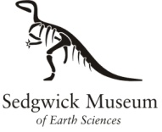
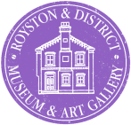
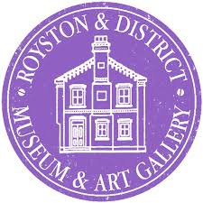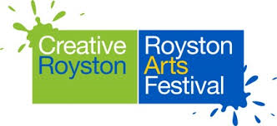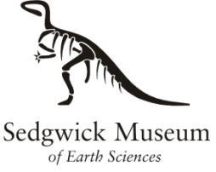

We are very fortunate that the staff and volunteers at Royston Museum have been behind us all the way as have the local schools and community magazines such as The Listing.

Premiere
Cracked Voices will premiere at Anglia Ruskin University on 10 March 2018.
www.cracked-voices.co.uk/tickets
https://www.anglia.ac.uk/arts-law-and-social-sciences/mumford-theatre/whats-on

